Protocol Aware Network Traffic Classification Framework in SDN using Machine Learning

Chaitali Bhownik
School of Computer and Systems Sciences
Jawaharlal Nehru University
New Delhi, India
diya.june2007@gmail.com

Dr. Tirthankar Gayen
School of Computer and Systems Sciences
Jawaharlal Nehru University
New Delhi, India
tirthankar@mail.jnu.ac.in

Abstract— Software Deﬁned Network (SDN) decouples arrange control and sending capacities, empowering system control to turn out to be straightforwardly a programmable network and the fundamental framework that is disconnected from various applications programs and system services. Traffic classification in SDN is very crucial as the unique feature of SDN can be exploited for better traffic management, flow control, security, reliability and overall performance of the network. With the help of Machine Learning (ML) algorithm network traffic can be classified that helps in better decision making beforehand. In this paper a protocol aware traffic classification framework has been proposed which is able to classify the network traffic based on different flow features. This helps in identifying different protocol patterns which transitively helps in identifying benign and anomalous traffic in a network and enhances the performance of a network by minimizing the interprotocol communication time. Different supervised algorithms have been used to compare the accuracy of predicting the protocol and classifying network traffic.
Keywords—Software Defined Network, Machine Learning, Supervised Learning, Traffic Classification

Introduction
Software defined network (SDN) is an architecture for networking which is different from traditional networking system. Before the invention of SDN the network constituted of switches which acted as the decision making as well as the forwarding device. But in SDN this has been changed.
The different components of the SDN architecture constitutes of application layer, the control layer and the infrastructure layer which basically contains SDN application, SDN controllers and SDN switches those are actually the data plane devices. OpenFlow protocol which is a communication protocol on top of TCP is used in SDN. The SDN southbound interface helps to communicate between control layer and infrastructure layer. The northbound interface is used to communicate between the control layer and application layer. The southbound connection can be exploited in two different types of bands such as i)in-band connection where the controller and devices communicate using some predefined flow rule and ii)out-of-band where the predefined rules are not followed and OpenFlow rules are maintained with the implementation of VLAN.
The use of this new paradigm has enabled the traffic engineering to be done with less time and CPU resources. The traffic classification can be done using various methods such as 1) Port based, 2) Payload based and 3) Machine learning based methods.

Port based: this method is dependent on the principal that the well known applications run on fixed port numbers. In this method we can identify an application from the port number it is using. Though this is the easiest and fastest method for identifying network traffic application but the problem with this method is nowadays most of the applications use dynamic port numbers which has stopped the use of port based methods for traffic classifications.

Payload based: this method can be categorized in two types such as 1)Deep Packet Inspection (DPI) and L3/L4 AccessList depending on processing method used.Here the payload of a data packet is analysed using signature based methods to get the idea of the incoming traffic.Though this technique provides a good accuracy but it is very much resource consuming and hampers users privacy.

Machine Learning based:these techniques exploit different machine learning algorithms such as Supervised ,Unsupervised, Semisupervised and Reinforcement learning. Though the accuracy of these techniques may be less than DPI but they are ususally less resource consuming, able to predict encrypted traffic and computationally less expensive.So the motive is to use them for traffic classification.
Traffic classification has been dealt with various perspectives such as Flow aware, QoS aware or Application aware traffic classification. In Flow aware classification the traffic is classified on the basis of bandwidth consumption and duration. There are mainly two types of flows such as Elephant flows which are long lived and utilize huge bandwidth. Whereas Mice flows are short lived and consumes bandwidth less than 10KB.The network traffic constitutes both these types of flows. For example in Data Center Networks 80% traffic is elephant flows and only 20% are mice flows. In QoS aware classification the traffic is categorized as per the QoS classes which are categorized on the basis of parameters like jitter, delay, loss etc. This helps in better resource optimization. In Application aware classification the traffic is classified as per the application in a network which is not a realistic approach as the number of applications in a network is increasing in a high rate.
Many researchers have studied these methods of classifications but in this paper a new type of classification have been proposed which is on the basis of protocols. The traffic is classified as per the underlying protocol which is used by different applications or data packets. With the blast of internet applications and network traffic there are huge number of complex protocols, topologies and network environments in use which increases the time to interact between different protocols. With the identification of proper protocol the interprotocol communication time can be minimized which will benefit in enhanced network performance. With our proposed technique we will be able to identify the protocols with an acceptable accuracy rate that could be used to analyze the network traffic within a less time period. The contributions of importance of this paper are
1) A real time protocol aware traffic classification technique has been proposed which can be applied for networks with an acceptable accuracy.
2) The result obtained from different machine learning algorithms have been compared to show the appropriateness/applicability of these algorithms in traffic classification.
3) A new category of traffic classification is introduced that has been tested on real life data.
The rest of the paper is organized as follows: in Section II the related work is provided; the details of the Protocol-aware traffic classification framework are available in Section III; Section IV describes the evaluation process and provides the results; and a conclusion of this paper is given in Section V.

Related Work

Traffic classification that is used for fine grained network management is required for various operations like routing, anomaly detection, resource allocation, security and enhancing the performance of the networks. Earlier only port based methods were used followed by payload based methods. But ML based methods have drawn the attention because of its less resource requirement. Many authors have used ML with DPI to get a good trade-off between accuracy and complexity. [li2014] used DPI and ML together as a multiclassifier for application layer traffic classification.[Silva2015] used Genetic Algorithm and SVM for selection of suitable flow features for traffic classification.[Chen2015] proposed a ML based routing pre-plan architecture for enterprise network using flow feature extraction and path selection by exploiting the distributed architecture of SDN.[xiao2015] used Decision Tree to identify backbone or elephant flow with low cost in Data Center Network.[Wang2016] designed a framework for QoS aware traffic classification using semi supervised algorithm.[amaral2016] described a simple architecture for data collection and traffic classification in an enterprise network.[ santosdasilva2016] proposed Atlantic which is used in campus network for anomaly traffic detection, classification and mitigation.[1.main] also proposed a QoS aware traffic classification which is based on ML and DPI.[10.1145] has shown how to do media traffic classification using Deep learning techniques.[sawabe2019] in his paper identified different Smartphone applications using encrypted traffic analysis.
Most researchers have done the traffic classification on the basis of QoS , flow or application traffic. In this paper the new approach of traffic classification on the basis of protocol using ML have been discussed.

A protocol-aware traffic classification framework
Our proposed framework is divided into four different modules. There is a) a data collector module , b) data pacifier module , c) ML based traffic classifier module and d) an optional re- trainer module. An overview of the framework is shown in Fig. 1.The modules are placed in the control plane because of the global knowledge of the controller.
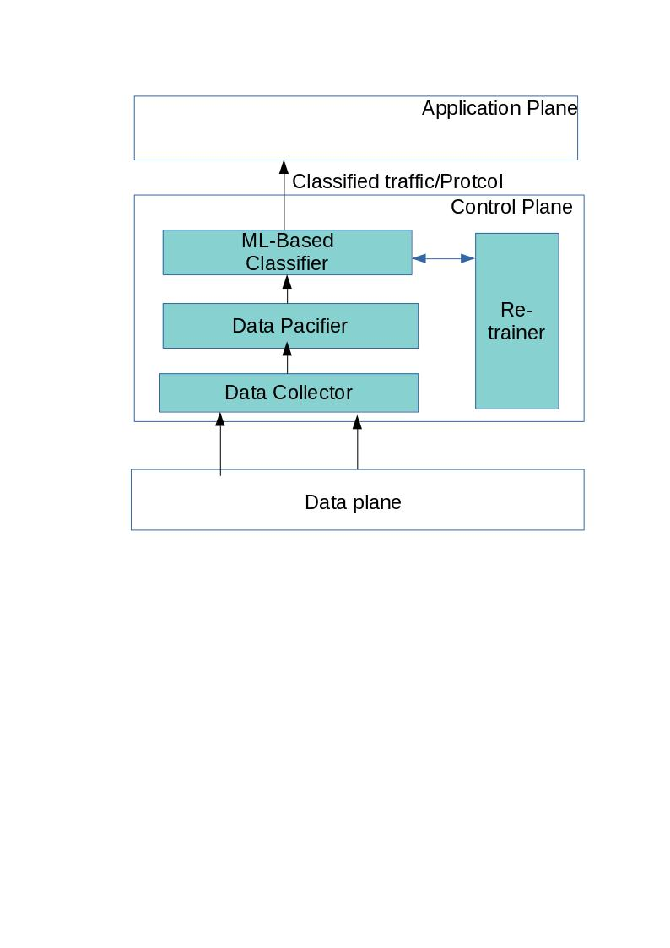
Fig. 1

a) The data plane elements ( OpenFlow switches) collect the overall network traffic.These collected flows are then sent to the control plane where the data collector module takes these data as input.The network flow data contain different features like packet characteristics such as packet length, Data flow time characteristics such as inter-arrival time of data flow, characteristics related to protocol such as packet source and destination port number and random information like hurst parameter.
b) The collected packets are then sent to the data pacifier module which will search for any irrelevant, redundant and erroneous data in the collected flow and modify them accordingly. The modified data will be restructured or pacified to a uniform and simple form so that those data will be fit for applying to the machine learning model.
c) The pacified data is given as input to the ML based traffic classifier module .This module is using supervised machine learning algorithm which works on labelled data. For our experimental purpose we have used Decision Tree, Multinominal Naïve Bayes, KNN, SVM and Random Forest algorithms as they are easy to implement and works fine with a moderate data set.This module classifies the network flow as per different protocols used during the training time.
d) The re-trainer module is an optional module. ML based models sometimes are not able to classify the incoming flow data accurately as they lack proper training data to identify new dataset. That is why we need to re train those models after some specific time interval. It helps in increasing the classifier accuracy and classification of new protocols with ease.

Experiment and Result

1) Data Collection: For collection of real-life network flow data a packet sniffing tool Wireshark is used. Collected data is stored in csv format. Some of the considered features are length, timestamps, inter-arrival time of the packets, the MAC and IP source and destination addresses, the duration of flow, the byte count and the packet count of the connection. Selection of features for classification is very important as the accuracy of the classifier depends on the features selected. For selection of advanced features we can refer to [silva2015]

2) Data Pacification: In this module firstly all the erroneous entries have been resolved from the dataset. It consists of dealing with duplicate data, inaccurate data, wrongly formatted data and extra spaces.
For performing the above task some of the Python functions have been used which are present in Pandas library. Table 2 contains the functions those have been used.

Table.1-Functions Used

Functions | Description
drop( ) | To delete any row or column(specifically)
drop_duplicates( ) | To delete duplicate data from dataset
isnull( ) | To check missing data(NaN)
dropna( ) | To delete null values

Till now, mostly all the inaccurate record have been excluded from the dataset. But Dataset still have some of the columns which contain categorical values. Feeding categorical data in ML models make their performance worst, to overcome this problem Encoding is used so that categorical data is converted into supported form. Some suitable encoding has been used for solving this problem .That encoding help in using categorical data in various estimation models. It uses only 1’s and 0’s to show all of the required information on group membership. Suppose any categorical column has n different values, it will convert that column into n columns. If our dataset has total k categorical columns and each of them contain some n categorical value, so after encoding we will have k*n columns. Fig 3 & 4 show partial view of the dataset with limited features before and after the encoding technique is applied.

3) Model training and testing: The captured real life network flow data from a campus network is divided into training and testing dataset in the ratio of 8:2.The training dataset is being fitted to the 5 different traffic classifiers separately. Remaining 20% test data is kept aside so that to test the classifier later after training. We have used 10 fold cross validation which is a standard for applied machine learning. Here the dataset is shuffled and is divided into 10 groups. Then each model is trained with any 8 groups of data and tested with remaining 2groups of data. The same applies for all 5 different algorithms. This is done for resampling of data with low bias.

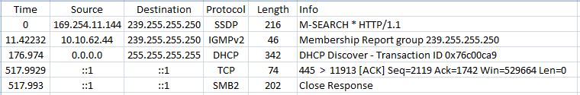
Fig.3-Before Encoding

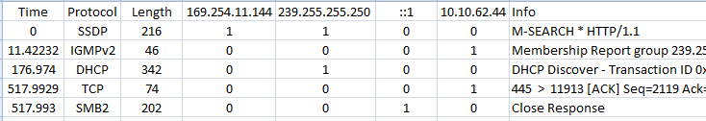
Fig.4-After Encoding
4) Evaluation: For the performance evaluation we have calculated four performance metrics which are a) Accuracy, b) Recall, c) Precision and d) F1 score

The accuracy is calculated as:
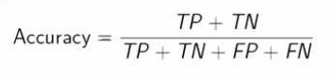

Precision Table
Protocols | Naïve Bayes | KNN | Random forest | Support Vector
DHCP  IGMPv2  NBNS  SMB2 | 0.238  0.000  0.143  0.765 | 1.000  0.000  1.000  0.974 | 1.000  0.000  1.000  0.974 | 1.000  1.000  1.000  0.974
SSDP  TCP | 0.839  0.682 | 0.875  0.977 | 1.000  0.955 | 1.000  1.000

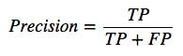
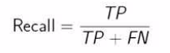

Conclusion

In this paper a Protocol aware traffic classification framework has been proposed which can work for campus or enterprise network.Our traffic classifier has shown good accuracy for different machine learning algorithms on real life campus network traffic.Coming to the ML algorithms, SVM has best accuracy whereas Naïve Bayes has shown less accuracy.But overall from this study it can be inferred that ML based traffic classifiers are demonstrating good performance while coming to traffic classification based on network protocol. With the help of protocol prediction there is an increase in the overall performance of the network by minimizing the interprotocol latency which our framework is able to achieve.
In future we are planning to focus on addition of more flow features to our classifier and inculcate deep learning model for re trainer module so that our framework becomes robust.

Authors and Affiliations
The template is designed for, but not limited to, six authors. A minimum of one author is required for all conference articles. Author names should be listed starting from left to right and then moving down to the next line. This is the author sequence that will be used in future citations and by indexing services. Names should not be listed in columns nor group by affiliation. Please keep your affiliations as succinct as possible (for example, do not differentiate among departments of the same organization).

For papers with more than six authors: Add author names horizontally, moving to a third row if needed for more than 8 authors.

For papers with less than six authors: To change the default, adjust the template as follows.

Selection: Highlight all author and affiliation lines.

Change number of columns: Select the Columns icon from the MS Word Standard toolbar and then select the correct number of columns from the selection palette.

Deletion: Delete the author and affiliation lines for the extra authors.

Identify the Headings
Headings, or heads, are organizational devices that guide the reader through your paper. There are two types: component heads and text heads.
Component heads identify the different components of your paper and are not topically subordinate to each other. Examples include Acknowledgments and References and, for these, the correct style to use is “Heading 5”. Use “figure caption” for your Figure captions, and “table head” for your table title. Run-in heads, such as “Abstract”, will require you to apply a style (in this case, italic) in addition to the style provided by the drop down menu to differentiate the head from the text.
Text heads organize the topics on a relational, hierarchical basis. For example, the paper title is the primary text head because all subsequent material relates and elaborates on this one topic. If there are two or more sub-topics, the next level head (uppercase Roman numerals) should be used and, conversely, if there are not at least two sub-topics, then no subheads should be introduced. Styles named “Heading 1”, “Heading 2”, “Heading 3”, and “Heading 4” are prescribed.

Figures and Tables

Positioning Figures and Tables: Place figures and tables at the top and bottom of columns. Avoid placing them in the middle of columns. Large figures and tables may span across both columns. Figure captions should be below the figures; table heads should appear above the tables. Insert figures and tables after they are cited in the text. Use the abbreviation “Fig. 1”, even at the beginning of a sentence.
- Table Type Styles
Table Head | Table Column Head
Table Head | Table column subhead | Subhead | Subhead
copy | More table copyª
- Sample of a Table footnote. (Table footnote)
- Example of a figure caption. (figure caption)
Figure Labels: Use 8 point Times New Roman for Figure labels. Use words rather than symbols or abbreviations when writing Figure axis labels to avoid confusing the reader. As an example, write the quantity “Magnetization”, or “Magnetization, M”, not just “M”. If including units in the label, present them within parentheses. Do not label axes only with units. In the example, write “Magnetization (A/m)” or “Magnetization {A[m(1)]}”, not just “A/m”. Do not label axes with a ratio of quantities and units. For example, write “Temperature (K)”, not “Temperature/K”.

Acknowledgment (Heading 5)
The preferred spelling of the word “acknowledgment” in America is without an “e” after the “g”. Avoid the stilted expression “one of us (R. B. G.) thanks ...”. Instead, try “R. B. G. thanks...”. Put sponsor acknowledgments in the unnumbered footnote on the first page.

References
The template will number citations consecutively within brackets [1]. The sentence punctuation follows the bracket [2]. Refer simply to the reference number, as in [3]—do not use “Ref. [3]” or “reference [3]” except at the beginning of a sentence: “Reference [3] was the first ...”
Number footnotes separately in superscripts. Place the actual footnote at the bottom of the column in which it was cited. Do not put footnotes in the abstract or reference list. Use letters for table footnotes.
Unless there are six authors or more give all authors’ names; do not use “et al.”. Papers that have not been published, even if they have been submitted for publication, should be cited as “unpublished” [4]. Papers that have been accepted for publication should be cited as “in press” [5]. Capitalize only the first word in a paper title, except for proper nouns and element symbols.
For papers published in translation journals, please give the English citation first, followed by the original foreign-language citation [6].

- G. Eason, B. Noble, and I. N. Sneddon, “On certain integrals of Lipschitz-Hankel type involving products of Bessel functions,” Phil. Trans. Roy. Soc. London, vol. A247, pp. 529–551, April 1955. (references)
- J. Clerk Maxwell, A Treatise on Electricity and Magnetism, 3rd ed., vol. 2. Oxford: Clarendon, 1892, pp.68–73.
- I. S. Jacobs and C. P. Bean, “Fine particles, thin films and exchange anisotropy,” in Magnetism, vol. III, G. T. Rado and H. Suhl, Eds. New York: Academic, 1963, pp. 271–350.
- K. Elissa, “Title of paper if known,” unpublished.
- R. Nicole, “Title of paper with only first word capitalized,” J. Name Stand. Abbrev., in press.
- Y. Yorozu, M. Hirano, K. Oka, and Y. Tagawa, “Electron spectroscopy studies on magneto-optical media and plastic substrate interface,” IEEE Transl. J. Magn. Japan, vol. 2, pp. 740–741, August 1987 [Digests 9th Annual Conf. Magnetics Japan, p. 301, 1982].
- M. Young, The Technical Writer’s Handbook. Mill Valley, CA: University Science, 1989.

IEEE conference templates contain guidance text for composing and formatting conference papers. Please ensure that all template text is removed from your conference paper prior to submission to the conference. Failure to remove template text from your paper may result in your paper not being published.

We suggest that you use a text box to insert a graphic (which is ideally a 300 dpi TIFF or EPS file, with all fonts embedded) because, in an MSW document, this method is somewhat more stable than directly inserting a picture.
To have non-visible rules on your frame, use the MSWord “Format” pull-down menu, select Text Box > Colors and Lines to choose No Fill and No Line.

